L.G.R.J.Lindapitiya

ICT/19/20/132(5066)

Abstract

Streamline event management with this application, offering seamless sign-up, event creation, task assignment, guest management, and client interaction. Simplify planning and execution with user-friendly features and efficient tools.

EVENT MANAGEMENT

MOBILE APPLICATION

This application is designed for an event management company to conveniently interact with their customers.  
**Link to reach GitHub**: <https://github.com/randilujayani31/randilujayani318.git>

**Event Planning Page**

This page consists of two text views to enter email and password. Users can access the system by entering these details and clicking the "Sign In" button. Additionally, there are buttons for both signing in and signing up. If a user hasn't signed up yet, they can click the "Sign Up" button to access the sign-up page.

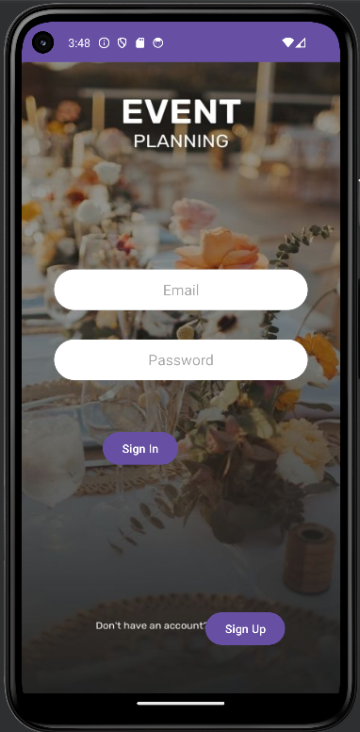

**Eventplanning.java**package com.example.eventplanning1;  
  
import androidx.appcompat.app.AppCompatActivity;  
  
import android.annotation.SuppressLint;  
import android.os.Bundle;  
import android.content.Intent;  
import android.os.Bundle;  
import android.view.View;  
import android.widget.Button;  
import android.widget.EditText;  
import android.widget.TextView;  
import android.widget.Toast;  
import androidx.appcompat.app.AppCompatActivity;  
  
public class MainActivty3 extends AppCompatActivity {  
  
 // Define variables for views and database handler  
 private EditText emailEdt, passwordEdt;  
 private Button loginBtn, signupbtn;  
  
 private DBHandler dbHandler;  
  
 private TextView signuptxt;  
  
 @SuppressLint("MissingInflatedId")  
 @Override  
 protected void onCreate(Bundle savedInstanceState) {  
 super.onCreate(savedInstanceState);  
 setContentView(R.layout.*activity_main3*);  
  
 // Initialize views  
 emailEdt = findViewById(R.id.*txtEmail*);  
 passwordEdt = findViewById(R.id.*txtPassword*);  
 loginBtn = findViewById(R.id.*btnsignin*);  
 signupbtn = findViewById(R.id.*btnsignup*);  
  
 // Initialize DBHandler  
 dbHandler = new DBHandler(this);  
  
 // Set OnClickListener for login button  
 loginBtn.setOnClickListener(new View.OnClickListener() {  
 @Override  
 public void onClick(View v) {  
 // Get user input  
 String email = emailEdt.getText().toString();  
 String password = passwordEdt.getText().toString();  
  
 // Validate input  
 if (email.isEmpty() || password.isEmpty()) {  
 Toast.*makeText*(MainActivty3.this, "Please enter email and password", Toast.*LENGTH_SHORT*).show();  
 return;  
 }  
  
 // Check if email and password match  
 if (dbHandler.checkLogin(email, password)) {  
 // If login successful, redirect to customer home activity  
 Intent intent = new Intent(MainActivty3.this, event_creation.class);  
 startActivity(intent);  
 finish(); // Finish LoginActivity to prevent going back  
 } else {  
 // If login unsuccessful, display error message  
 Toast.*makeText*(MainActivty3.this, "Invalid email or password", Toast.*LENGTH_SHORT*).show();  
 }  
 }  
 });  
  
 signupbtn.setOnClickListener(new View.OnClickListener() {  
 @Override  
 public void onClick(View v) {  
 startActivity(new Intent(MainActivty3.this, sign_up.class));  
 }  
 });  
  
  
  
 }  
}

**Eventplanning.xml**<?xml version="1.0" encoding="utf-8"?>  
<androidx.constraintlayout.widget.ConstraintLayout xmlns:android="http://schemas.android.com/apk/res/android"  
 xmlns:app="http://schemas.android.com/apk/res-auto"  
 xmlns:tools="http://schemas.android.com/tools"  
 android:id="@+id/preferences"  
 android:layout_width="match_parent"  
 android:layout_height="match_parent"  
 tools:context=".MainActivty3">  
  
 <ImageView  
 android:id="@+id/imageView"  
 android:layout_width="wrap_content"  
 android:layout_height="wrap_content"  
 android:scaleType="fitXY"  
 app:layout_constraintStart_toStartOf="parent"  
 app:layout_constraintTop_toTopOf="parent"  
 app:srcCompat="@drawable/_1" />  
  
 <EditText  
 android:id="@+id/txtEmail"  
 android:layout_width="match_parent"  
 android:layout_height="50dp"  
 android:layout_alignParentStart="true"  
 android:layout_alignParentTop="true"  
 android:layout_marginStart="40dp"  
 android:layout_marginEnd="40dp"  
 android:layout_marginBottom="472dp"  
 android:background="@drawable/textbackground"  
 android:ems="10"  
 android:inputType="textEmailAddress"  
 android:hint="Email"  
 android:textAlignment="center"  
 android:textColor="@color/black"  
 app:layout_constraintBottom_toBottomOf="parent"  
 app:layout_constraintStart_toStartOf="parent" />  
  
 <EditText  
 android:id="@+id/txtPassword"  
 android:layout_width="match_parent"  
 android:layout_height="50dp"  
 android:layout_alignParentStart="true"  
 android:layout_alignParentTop="true"  
 android:layout_marginStart="40dp"  
 android:layout_marginTop="36dp"  
 android:layout_marginEnd="40dp"  
 android:background="@drawable/textbackground"  
 android:inputType="textPassword"  
 android:ems="10"  
 android:textAlignment="center"  
 android:hint="Password"  
 android:textColor="@color/black"  
 app:layout_constraintStart_toStartOf="@+id/txtEmail"  
 app:layout_constraintTop_toBottomOf="@+id/txtEmail" />  
  
 <Button  
 android:id="@+id/btnsignin"  
 android:layout_width="wrap_content"  
 android:layout_height="wrap_content"  
 android:layout_marginStart="20dp"  
 android:layout_marginTop="60dp"  
 android:text="Sign In"  
 app:layout_constraintStart_toStartOf="@+id/txtPassword"  
 app:layout_constraintTop_toBottomOf="@+id/txtPassword" />  
  
 <Button  
 android:id="@+id/btnsignup"  
 android:layout_width="wrap_content"  
 android:layout_height="wrap_content"  
 android:layout_marginEnd="68dp"  
 android:layout_marginBottom="56dp"  
 android:text="Sign Up"  
 app:layout_constraintBottom_toBottomOf="parent"  
 app:layout_constraintEnd_toEndOf="parent" />  
  
</androidx.constraintlayout.widget.ConstraintLayout>

**Sign Up Page**

The sign-up page comprises five text views to enter email, full name, username, password, and confirm password. Users can sign up by entering these details and clicking the "Sign Up" button. Similarly, there are buttons for signing in and signing up. If a user has already signed up, they can click the "Sign In" button to access the login page.

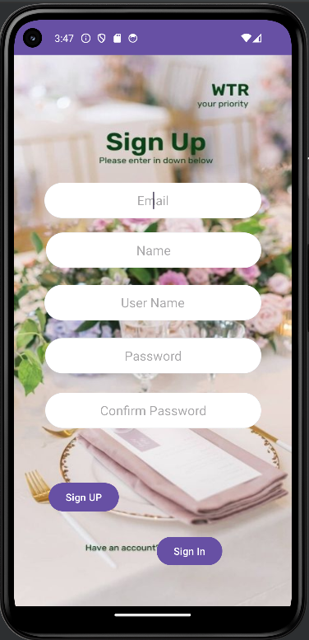

**Signup.java**package com.example.eventplanning1;  
  
import android.annotation.SuppressLint;  
import android.content.Intent;  
import android.os.Bundle;  
import android.view.View;  
import android.widget.Button;  
import android.widget.EditText;  
import android.widget.Toast;  
import com.example.eventplanning1.MainActivty3;  
  
  
import androidx.appcompat.app.AppCompatActivity;  
  
public class sign_up extends AppCompatActivity {  
  
 // creating variables for our edittext, button and dbhandler  
 private EditText emailEditText, fullNameEditText, usernameEditText, passwordEditText, confirmPasswordEditText;  
 private Button signUpButton, signInButton;  
 private DBHandler dbHandler;  
  
 @SuppressLint("MissingInflatedId")  
 @Override  
 protected void onCreate(Bundle savedInstanceState) {  
 super.onCreate(savedInstanceState);  
 setContentView(R.layout.*activity_sign_up*);  
  
 // initializing all our variables.  
 emailEditText = findViewById(R.id.*editEmailAddress*);  
 fullNameEditText = findViewById(R.id.*editTextName*);  
 usernameEditText = findViewById(R.id.*editTextUsername*);  
 passwordEditText = findViewById(R.id.*editTextPassword*);  
 confirmPasswordEditText = findViewById(R.id.*editTextConfirmPassword*);  
 signUpButton = findViewById(R.id.*signup1*);  
 signInButton = findViewById(R.id.*signin1*);  
  
 // creating a new dbhandler class  
 // and passing our context to it.  
 dbHandler = new DBHandler(this);  
  
 // below line is to add on click listener for our sign up button.  
 signUpButton.setOnClickListener(new View.OnClickListener() {  
 @Override  
 public void onClick(View v) {  
  
 // below line is to get data from all edit text fields.  
 String email = emailEditText.getText().toString();  
 String fullName = fullNameEditText.getText().toString();  
 String username = usernameEditText.getText().toString();  
 String password = passwordEditText.getText().toString();  
 String confirmPassword = confirmPasswordEditText.getText().toString();  
  
 // validating if any of the text fields are empty or not.  
 if (email.isEmpty() || fullName.isEmpty() || username.isEmpty() || password.isEmpty() || confirmPassword.isEmpty()) {  
 Toast.*makeText*(sign_up.this, "Please enter all the data..", Toast.*LENGTH_SHORT*).show();  
 return;  
 }  
 if (password.equals(confirmPassword)) {  
  
 // on below line we are calling a method to add new  
 // user to sqlite data and pass all our values to it.  
 dbHandler.addUser(email, fullName, username, password);  
  
 // below line is to check if the data is added successfully or not.  
  
 // if the data is added successfully  
 // we are displaying a toast message as user has signed up.  
 Toast.*makeText*(sign_up.this, "You have successfully signed up.", Toast.*LENGTH_SHORT*).show();  
 // after adding the data we are clearing all edittext fields.  
 emailEditText.setText("");  
 fullNameEditText.setText("");  
 usernameEditText.setText("");  
 passwordEditText.setText("");  
 confirmPasswordEditText.setText("");  
 Intent intent = new Intent(sign_up.this, MainActivty3.class);  
 // Start the sign-in activity  
 startActivity(intent);  
 // Finish the current activity (sign-up activity)  
 finish();  
  
  
 }  
 else {  
 Toast.*makeText*(sign_up.this, "Passwords do not match.", Toast.*LENGTH_SHORT*).show();  
 }  
 }  
  
  
 });  
  
 // Set onClickListener for sign-in button  
 signInButton.setOnClickListener(new View.OnClickListener() {  
 @Override  
 public void onClick(View v) {  
 // Create an Intent to start the sign-in activity  
 Intent intent = new Intent(sign_up.this, MainActivty3.class);  
 // Start the sign-in activity  
 startActivity(intent);  
 // Finish the current activity (sign-up activity)  
 finish();  
 }  
 });  
 }  
}

**Signup.xml**<?xml version="1.0" encoding="utf-8"?>  
<RelativeLayout xmlns:android="http://schemas.android.com/apk/res/android"  
 xmlns:app="http://schemas.android.com/apk/res-auto"  
 xmlns:tools="http://schemas.android.com/tools"  
 android:id="@+id/preferences"  
 android:layout_width="match_parent"  
 android:layout_height="match_parent"  
  
 android:background="@android:color/white"  
 tools:context=".sign_up">  
  
 <ImageView  
 android:id="@+id/imageView3"  
 android:layout_width="wrap_content"  
 android:layout_height="wrap_content"  
 android:scaleType="fitXY"  
 app:srcCompat="@drawable/_3" />  
  
 <EditText  
 android:id="@+id/editEmailAddress"  
 android:layout_width="match_parent"  
 android:background="@drawable/textbackground"  
 android:layout_height="50dp"  
 android:textAlignment="center"  
 android:layout_marginStart="43dp"  
 android:layout_marginEnd="43dp"  
 android:layout_alignParentStart="true"  
 android:layout_alignParentTop="true"  
 android:layout_marginTop="180dp"  
 android:layout_marginBottom="30dp"  
 android:ems="10"  
 android:hint="Email"  
 android:inputType="textEmailAddress" />  
  
 <EditText  
 android:id="@+id/editTextName"  
 android:layout_width="match_parent"  
 android:layout_height="50dp"  
 android:layout_alignParentStart="true"  
 android:layout_alignParentTop="true"  
 android:layout_marginStart="45dp"  
 android:layout_marginTop="250dp"  
 android:layout_marginEnd="43dp"  
 android:layout_marginBottom="30dp"  
 android:background="@drawable/textbackground"  
 android:ems="10"  
 android:hint="Name"  
 android:inputType="text"  
 android:textAlignment="center" />  
  
 <EditText  
 android:id="@+id/editTextUsername"  
 android:layout_width="match_parent"  
 android:layout_height="50dp"  
 android:layout_alignParentStart="true"  
 android:layout_alignParentTop="true"  
 android:layout_marginStart="43dp"  
 android:layout_marginTop="324dp"  
 android:layout_marginEnd="43dp"  
 android:layout_marginBottom="30dp"  
 android:background="@drawable/textbackground"  
 android:ems="10"  
 android:hint="User Name"  
 android:inputType="text"  
 android:text=""  
 android:textAlignment="center" />  
  
  
 <EditText  
 android:id="@+id/editTextPassword"  
 android:layout_width="match_parent"  
 android:layout_height="50dp"  
 android:layout_alignParentStart="true"  
 android:layout_alignParentTop="true"  
 android:layout_marginStart="44dp"  
 android:layout_marginTop="399dp"  
 android:layout_marginEnd="43dp"  
 android:layout_marginBottom="30dp"  
 android:background="@drawable/textbackground"  
 android:ems="10"  
 android:hint="Password"  
 android:inputType="textPassword"  
 android:text=""  
 android:textAlignment="center" />  
  
 <EditText  
 android:id="@+id/editTextConfirmPassword"  
 android:layout_width="match_parent"  
 android:layout_height="50dp"  
 android:layout_alignParentStart="true"  
 android:layout_alignParentTop="true"  
 android:layout_marginStart="44dp"  
 android:layout_marginTop="476dp"  
 android:layout_marginEnd="43dp"  
 android:layout_marginBottom="30dp"  
 android:background="@drawable/textbackground"  
 android:ems="10"  
 android:hint="Confirm Password"  
 android:inputType="textPassword"  
 android:text=""  
 android:textAlignment="center" />  
  
 <Button  
 android:id="@+id/signup1"  
 android:layout_width="wrap_content"  
 android:layout_height="wrap_content"  
 android:layout_alignParentStart="true"  
 android:layout_alignParentBottom="true"  
 android:layout_marginStart="49dp"  
 android:layout_marginBottom="130dp"  
 android:text="Sign UP" />  
  
 <Button  
 android:id="@+id/signin1"  
 android:layout_width="wrap_content"  
 android:layout_height="wrap_content"  
 android:layout_alignParentEnd="true"  
 android:layout_alignParentBottom="true"  
 android:layout_marginEnd="98dp"  
 android:layout_marginBottom="54dp"  
 android:text="Sign In" />  
  
</RelativeLayout>

**Event Creation Page**

After the event planning page, users are directed to the event creation page. Here, they can enter the event name and date, along with the location of the event. After entering these details, users can click the "Next" button to proceed.

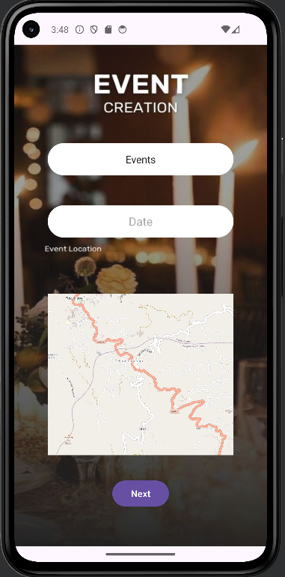

**Eventcreation.java**package com.example.eventplanning1;  
  
import android.content.Intent;  
import android.os.Bundle;  
import android.view.View;  
import android.widget.ArrayAdapter;  
import android.widget.Button;  
import android.widget.EditText;  
import android.widget.Spinner;  
import android.widget.Toast;  
  
import androidx.activity.EdgeToEdge;  
import androidx.appcompat.app.AppCompatActivity;  
import androidx.core.graphics.Insets;  
import androidx.core.view.ViewCompat;  
import androidx.core.view.WindowInsetsCompat;  
  
import org.osmdroid.config.Configuration;  
import org.osmdroid.events.MapEventsReceiver;  
import org.osmdroid.tileprovider.tilesource.TileSourceFactory;  
import org.osmdroid.views.MapView;  
import org.osmdroid.util.GeoPoint;  
import org.osmdroid.views.overlay.MapEventsOverlay;  
  
  
  
public class event_creation extends AppCompatActivity {  
  
 private Spinner eventSpinner; // Updated Spinner variable  
 private EditText eventDateEditText; // Updated EditText variable  
 private Button nextButton; // Updated Button variable  
  
 private DBHandler dbHandler;  
  
 @Override  
 protected void onCreate(Bundle savedInstanceState) {  
 super.onCreate(savedInstanceState);  
 EdgeToEdge.*enable*(this);  
 setContentView(R.layout.*activity_event_creation*);  
  
 Configuration.*getInstance*().setUserAgentValue("com.example.eventplanning1");  
  
 MapView map = findViewById(R.id.*map*);  
 map.setTileSource(TileSourceFactory.*MAPNIK*); // Set the tile source  
 map.setMultiTouchControls(true); // Enable multi-touch zoom and pan  
 // Set the default map center coordinates (Rajarata University of Sri Lanka)  
 GeoPoint startPoint = new GeoPoint(7.096261, 80.645934);  
 map.getController().setCenter(startPoint);  
 map.getController().setZoom(15.0);  
 // Create a custom implementation of MapEventsReceiver  
 MapEventsReceiver mapEventsReceiver = new MapEventsReceiver() {  
 @Override  
 public boolean singleTapConfirmedHelper(GeoPoint p) {  
 // Convert the tapped geo point to latitude and longitude  
 double latitude = p.getLatitude();  
 double longitude = p.getLongitude();  
 // Display a toast message with the coordinates  
 String message = "Tapped Location - Latitude: " + latitude + ", Longitude: " +  
 longitude;  
 Toast.*makeText*(event_creation.this, message, Toast.*LENGTH_SHORT*).show();  
 return true;  
 }  
  
 @Override  
 public boolean longPressHelper(GeoPoint p) {  
 return false;  
 }  
 };  
 // Add the MapEventsReceiver to the map  
 MapEventsOverlay mapEventsOverlay = new MapEventsOverlay(mapEventsReceiver);  
 map.getOverlays().add(0, mapEventsOverlay); // Add the overlay to the map  
  
  
 ViewCompat.*setOnApplyWindowInsetsListener*(findViewById(R.id.*preferences*), (v, insets) -> {  
 Insets systemBars = insets.getInsets(WindowInsetsCompat.Type.*systemBars*());  
 v.setPadding(systemBars.left, systemBars.top, systemBars.right, systemBars.bottom);  
 return insets;  
 });  
  
 //Declare spinner array  
 //String[] values = {"Events", "Wedding", "Birthday Parties", "Conference", "Meeting", "Mehendi Festival", "Anniversary Party","Others"};  
  
  
 // Initialize UI elements  
 eventSpinner = findViewById(R.id.*spinner*); // Initialize eventSpinner with the correct ID  
 eventDateEditText = findViewById(R.id.*date*); // Updated EditText ID  
 nextButton = findViewById(R.id.*next1*); // Updated Button ID  
  
  
 dbHandler = new DBHandler(event_creation.this);  
 //Declare spinner array  
 String[] values = {"Events", "Wedding", "Birthday Parties", "Conference", "Meeting", "Mehendi Festival", "Anniversary Party","Others"};  
  
 // Create an ArrayAdapter using the string array and a default spinner layout  
 ArrayAdapter<String> adapter = new ArrayAdapter<>(this, android.R.layout.*simple_spinner_item*, values);  
 // Specify the layout to use when the list of choices appears  
 adapter.setDropDownViewResource(android.R.layout.*simple_spinner_dropdown_item*);  
  
 eventSpinner.setAdapter(adapter);  
  
 // Set click listener for next button  
 nextButton.setOnClickListener(new View.OnClickListener() {  
 @Override  
 public void onClick(View v) {  
 // Retrieve selected event from spinner  
 String selectedEvent = eventSpinner.getSelectedItem().toString();  
 // Retrieve event date from EditText field  
 String eventDate = eventDateEditText.getText().toString().trim();  
  
 // Perform validation (e.g., check if fields are empty)  
 if (selectedEvent.isEmpty()) {  
 Toast.*makeText*(event_creation.this, "Please enter all the data..", Toast.*LENGTH_SHORT*).show();  
 return;  
 }  
 nextButton.setOnClickListener(new View.OnClickListener() {  
 @Override  
 public void onClick(View v) {  
 // Start the theme activity  
 Intent intent = new Intent(event_creation.this, theme.class);  
 startActivity(intent);  
 }  
 });  
  
  
 // Save event details or perform other actions  
 dbHandler.eventCreation(selectedEvent,eventDate);  
  
 // For simplicity, let's just display a toast message  
 Toast.*makeText*(event_creation.this, "Event creation successful!", Toast.*LENGTH_SHORT*).show();  
  
 // Proceed to next page (if needed)  
 }  
  
  
 });  
  
  
 }  
}

**Eventcreation.xml**<?xml version="1.0" encoding="utf-8"?>  
<androidx.constraintlayout.widget.ConstraintLayout xmlns:android="http://schemas.android.com/apk/res/android"  
 xmlns:app="http://schemas.android.com/apk/res-auto"  
 xmlns:tools="http://schemas.android.com/tools"  
 android:id="@+id/preferences"  
 android:layout_width="match_parent"  
 android:layout_height="match_parent"  
 tools:context=".event_creation">  
  
 <ImageView  
 android:id="@+id/imageView2"  
 android:layout_width="wrap_content"  
 android:layout_height="wrap_content"  
 android:scaleType="fitXY"  
 app:layout_constraintStart_toStartOf="parent"  
 app:layout_constraintTop_toTopOf="parent"  
 app:srcCompat="@drawable/_6"  
 tools:ignore="MissingConstraints" />  
 <Spinner  
 android:id="@+id/spinner"  
 android:layout_width="match_parent"  
 android:layout_height="50dp"  
 android:background="@drawable/textbackground"  
 android:layout_marginStart="52dp"  
 android:layout_marginEnd="52dp"  
 android:textAlignment="center"  
  
 android:layout_marginTop="126dp"  
 android:layout_marginBottom="20dp"  
 app:layout_constraintBottom_toTopOf="@+id/date"  
 app:layout_constraintStart_toStartOf="parent"  
 app:layout_constraintTop_toTopOf="parent" />  
  
  
 <org.osmdroid.views.MapView  
 android:id="@+id/map"  
 android:layout_width="match_parent"  
 android:layout_marginStart="52dp"  
 android:layout_marginEnd="52dp"  
 android:layout_height="250dp"  
 android:layout_marginBottom="9dp"  
 app:layout_constraintBottom_toTopOf="@+id/next1"  
 app:layout_constraintEnd_toEndOf="parent"  
 app:layout_constraintStart_toStartOf="parent"  
 app:layout_constraintTop_toBottomOf="@+id/date"  
 tools:ignore="MissingConstraints">  
  
 </org.osmdroid.views.MapView>  
  
 <EditText  
 android:id="@+id/date"  
 android:layout_width="match_parent"  
 android:layout_height="50dp"  
 android:layout_marginBottom="61dp"  
 android:layout_marginEnd="52dp"  
 android:layout_marginStart="52dp"  
 android:ems="10"  
 android:inputType="date"  
 android:hint="Date"  
 android:background="@drawable/textbackground"  
 android:textColor="@color/black"  
 android:textAlignment="center"  
 app:layout_constraintBottom_toTopOf="@+id/map"  
 app:layout_constraintStart_toStartOf="@+id/spinner"  
 app:layout_constraintTop_toBottomOf="@+id/spinner"  
 tools:ignore="MissingConstraints" />  
  
 <Button  
 android:id="@+id/next1"  
 android:layout_width="wrap_content"  
 android:layout_height="wrap_content"  
 android:layout_marginBottom="32dp"  
 android:text="Next"  
 app:layout_constraintBottom_toBottomOf="parent"  
 app:layout_constraintEnd_toEndOf="parent"  
 app:layout_constraintStart_toStartOf="parent"  
 app:layout_constraintTop_toBottomOf="@+id/map" />  
  
  
</androidx.constraintlayout.widget.ConstraintLayout>

**Task Assignment Page**

Following the event creation page, users reach the event task assignment page. This page presents list view assigned for different tasks. Users can select relevant tasks using these list view buttons and click the "Next" button to move forward.

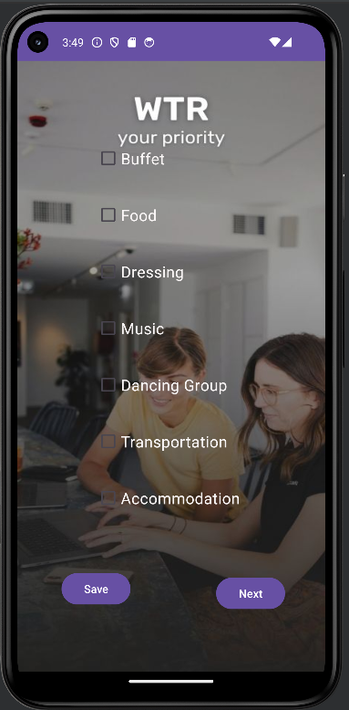

**Taskassignment.java**package com.example.eventplanning1;  
  
import android.annotation.SuppressLint;  
import android.content.Intent;  
import android.os.Bundle;  
import android.view.View;  
import android.widget.Button;  
import android.widget.CheckBox;  
import android.widget.Toast;  
  
import androidx.appcompat.app.AppCompatActivity;  
  
import java.util.ArrayList;  
import java.util.List;  
  
public class task_assignment extends AppCompatActivity {  
  
 private CheckBox checkBox1, checkBox2, checkBox3, checkBox4, checkBox5, checkBox6, checkBox7;  
 private Button nextButton, saveButton;  
 private DBHandler dbHandler;  
  
 @SuppressLint("MissingInflatedId")  
 @Override  
 protected void onCreate(Bundle savedInstanceState) {  
 super.onCreate(savedInstanceState);  
 setContentView(R.layout.*activity_task_assignment*);  
  
 // Initialize checkboxes  
 checkBox1 = findViewById(R.id.*checkbox1*);  
 checkBox2 = findViewById(R.id.*checkbox2*);  
 checkBox3 = findViewById(R.id.*checkbox3*);  
 checkBox4 = findViewById(R.id.*checkbox4*);  
 checkBox5 = findViewById(R.id.*checkbox5*);  
 checkBox6 = findViewById(R.id.*checkbox6*);  
 checkBox7 = findViewById(R.id.*checkbox7*);  
  
 nextButton = findViewById(R.id.*btnnext3*);  
 saveButton = findViewById(R.id.*btnSave*);  
  
 // Initialize database handler  
 dbHandler = new DBHandler(this);  
  
 saveButton.setOnClickListener(new View.OnClickListener() {  
 @Override  
 public void onClick(View v) {  
 // Handle checkbox selections  
 List<String> selectedItems = new ArrayList<>();  
 if (checkBox1.isChecked()) {  
 selectedItems.add(checkBox1.getText().toString());  
 }  
 if (checkBox2.isChecked()) {  
 selectedItems.add(checkBox2.getText().toString());  
 }  
 if (checkBox3.isChecked()) {  
 selectedItems.add(checkBox3.getText().toString());  
 }  
 if (checkBox4.isChecked()) {  
 selectedItems.add(checkBox4.getText().toString());  
 }  
 if (checkBox5.isChecked()) {  
 selectedItems.add(checkBox5.getText().toString());  
 }  
 if (checkBox6.isChecked()) {  
 selectedItems.add(checkBox6.getText().toString());  
 }  
 if (checkBox7.isChecked()) {  
 selectedItems.add(checkBox7.getText().toString());  
 }  
  
 if (!selectedItems.isEmpty()) {  
 // Store selected items in database  
 dbHandler.addChecklistItems(selectedItems);  
 // Show a success message  
 Toast.*makeText*(task_assignment.this, "Items saved", Toast.*LENGTH_SHORT*).show();  
 } else {  
 // If no items are selected, show a message  
 Toast.*makeText*(task_assignment.this, "No items selected", Toast.*LENGTH_SHORT*).show();  
 }  
 }  
 });  
  
 }  
  
 public void nextButton(View view) {  
 startActivity(new Intent(task_assignment.this, guest_management.class));  
 }  
}

**Taskassignment.java**package com.example.eventplanning1;  
  
public class CheckListItem {  
 private String name;  
 private boolean selected;  
  
 public CheckListItem(String name) {  
 this.name = name;  
 this.selected = false; // Initialize as not selected  
 }  
  
 public String getName() {  
 return name;  
 }  
  
 public boolean isSelected() {  
 return selected;  
 }  
  
 public void setSelected(boolean selected) {  
 this.selected = selected;  
 }  
}

**Taskassignment.xml**<?xml version="1.0" encoding="utf-8"?>  
<androidx.constraintlayout.widget.ConstraintLayout xmlns:android="http://schemas.android.com/apk/res/android"  
 xmlns:app="http://schemas.android.com/apk/res-auto"  
 xmlns:tools="http://schemas.android.com/tools"  
 android:id="@+id/main"  
 android:layout_width="match_parent"  
 android:layout_height="match_parent"  
 tools:context=".task_assignment">  
  
 <ImageView  
 android:id="@+id/imageView5"  
 android:layout_width="wrap_content"  
 android:layout_height="wrap_content"  
 android:scaleType="fitXY"  
 app:layout_constraintBottom_toBottomOf="parent"  
 app:layout_constraintEnd_toEndOf="parent"  
 app:layout_constraintHorizontal_bias="0.0"  
 app:layout_constraintStart_toStartOf="parent"  
 app:layout_constraintTop_toTopOf="parent"  
 app:layout_constraintVertical_bias="1.0"  
 app:srcCompat="@drawable/_12" />  
  
 <CheckBox  
 android:id="@+id/checkbox1"  
 android:layout_width="wrap_content"  
 android:layout_height="wrap_content"  
 android:layout_marginStart="100dp"  
 android:layout_marginTop="100dp"  
 android:text="Buffet"  
 android:textColor="#FAF6F6"  
  
 android:textSize="20sp"  
 app:layout_constraintStart_toStartOf="parent"  
 app:layout_constraintTop_toTopOf="parent" />  
  
 <CheckBox  
 android:id="@+id/checkbox2"  
 android:layout_width="wrap_content"  
 android:layout_height="wrap_content"  
 android:layout_marginTop="24dp"  
 android:text="Food"  
 android:textColor="#FAF6F6"  
 android:textSize="20sp"  
 app:layout_constraintStart_toStartOf="@+id/checkbox1"  
 app:layout_constraintTop_toBottomOf="@+id/checkbox1" />  
  
 <CheckBox  
 android:id="@+id/checkbox3"  
 android:layout_width="wrap_content"  
 android:layout_height="wrap_content"  
 android:layout_marginTop="24dp"  
 android:text="Dressing"  
 android:textColor="#FAF6F6"  
 android:textSize="20sp"  
 app:layout_constraintStart_toStartOf="@+id/checkbox2"  
 app:layout_constraintTop_toBottomOf="@+id/checkbox2" />  
  
 <CheckBox  
 android:id="@+id/checkbox4"  
 android:layout_width="wrap_content"  
 android:layout_height="wrap_content"  
 android:layout_marginTop="24dp"  
 android:text="Music"  
 android:textColor="#FAF6F6"  
 android:textSize="20sp"  
 app:layout_constraintStart_toStartOf="@+id/checkbox3"  
 app:layout_constraintTop_toBottomOf="@+id/checkbox3" />  
  
 <CheckBox  
 android:id="@+id/checkbox5"  
 android:layout_width="wrap_content"  
 android:layout_height="wrap_content"  
 android:layout_marginTop="24dp"  
 android:text="Dancing Group"  
 android:textColor="#FAF6F6"  
 android:textSize="20sp"  
 app:layout_constraintStart_toStartOf="@+id/checkbox4"  
 app:layout_constraintTop_toBottomOf="@+id/checkbox4" />  
  
 <CheckBox  
 android:id="@+id/checkbox6"  
 android:layout_width="wrap_content"  
 android:layout_height="wrap_content"  
 android:layout_marginTop="24dp"  
 android:text="Transportation"  
 android:textColor="#FAF6F6"  
 android:textSize="20sp"  
 app:layout_constraintStart_toStartOf="@+id/checkbox5"  
 app:layout_constraintTop_toBottomOf="@+id/checkbox5" />  
  
 <CheckBox  
 android:id="@+id/checkbox7"  
 android:layout_width="wrap_content"  
 android:layout_height="wrap_content"  
 android:layout_marginTop="24dp"  
 android:text="Accommodation"  
 android:textColor="#FAF6F6"  
 android:textSize="20sp"  
 app:layout_constraintStart_toStartOf="@+id/checkbox6"  
 app:layout_constraintTop_toBottomOf="@+id/checkbox6" />  
  
 <Button  
 android:id="@+id/btnnext3"  
 android:layout_width="wrap_content"  
 android:layout_height="wrap_content"  
 android:layout_marginBottom="76dp"  
 android:text="Next"  
 android:onClick="nextButton"  
 app:layout_constraintBottom_toBottomOf="parent"  
 app:layout_constraintEnd_toEndOf="parent"  
 app:layout_constraintHorizontal_bias="0.832"  
 app:layout_constraintStart_toStartOf="parent" />  
  
 <Button  
 android:id="@+id/btnSave"  
 android:layout_width="wrap_content"  
 android:layout_height="wrap_content"  
 android:text="Save"  
 app:layout_constraintBottom_toBottomOf="parent"  
 app:layout_constraintEnd_toEndOf="parent"  
 app:layout_constraintHorizontal_bias="0.185"  
 app:layout_constraintStart_toStartOf="parent"  
 app:layout_constraintTop_toTopOf="parent"  
 app:layout_constraintVertical_bias="0.888" />  
</androidx.constraintlayout.widget.ConstraintLayout>

**Checklist.xml**<?xml version="1.0" encoding="utf-8"?>  
<androidx.constraintlayout.widget.ConstraintLayout xmlns:android="http://schemas.android.com/apk/res/android"  
 android:layout_width="match_parent"  
 android:layout_height="wrap_content"  
 xmlns:app="http://schemas.android.com/apk/res-auto">  
  
 <CheckBox  
 android:id="@+id/checkBox"  
 android:layout_width="wrap_content"  
 android:layout_height="wrap_content"  
 android:text="Checklist Item"  
 android:padding="10dp"  
 android:textSize="16sp"  
 android:textColor="@android:color/black"  
 android:layout_margin="8dp"  
 android:layout_marginTop="8dp"  
 android:layout_marginBottom="8dp"  
 app:layout_constraintStart_toStartOf="parent"  
 app:layout_constraintTop_toTopOf="parent"  
 app:layout_constraintBottom_toBottomOf="parent"/>  
  
</androidx.constraintlayout.widget.ConstraintLayout>

**Additional Task Assignment Page**

This page, also part of the task assignment section, allows users to specify the event theme and any other preferences besides those entered in the task assignment. After providing this information, users can click the "Next" button.

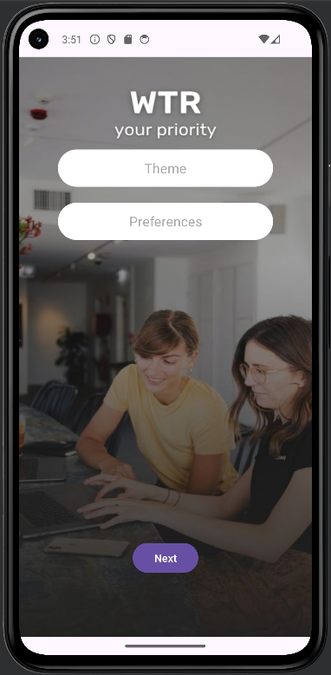

**Theme.java**package com.example.eventplanning1;  
  
import android.content.Intent;  
import android.os.Bundle;  
import android.view.View;  
import android.widget.Button;  
import android.widget.EditText;  
import android.widget.Toast;  
  
import androidx.activity.EdgeToEdge;  
import androidx.appcompat.app.AppCompatActivity;  
import androidx.core.graphics.Insets;  
import androidx.core.view.ViewCompat;  
import androidx.core.view.WindowInsetsCompat;  
  
public class theme extends AppCompatActivity {  
  
 private EditText themeNameEdt, preferencesEdt;  
 private Button nextButton;  
 private DBHandler dbHandler;  
  
 @Override  
 protected void onCreate(Bundle savedInstanceState) {  
 super.onCreate(savedInstanceState);  
 EdgeToEdge.*enable*(this);  
 setContentView(R.layout.*activity_theme*);  
 ViewCompat.*setOnApplyWindowInsetsListener*(findViewById(R.id.*preferences*), (v, insets) -> {  
 Insets systemBars = insets.getInsets(WindowInsetsCompat.Type.*systemBars*());  
 v.setPadding(systemBars.left, systemBars.top, systemBars.right, systemBars.bottom);  
 return insets;  
 });  
  
 // Initialize UI elements  
 themeNameEdt = findViewById(R.id.*themename*);  
 preferencesEdt = findViewById(R.id.*pref*);  
 nextButton = findViewById(R.id.*next3*);  
  
 // Initialize DBHandler  
 dbHandler = new DBHandler(theme.this);  
  
 // Set click listener for next button  
 nextButton.setOnClickListener(new View.OnClickListener() {  
 @Override  
 public void onClick(View v) {  
 // Retrieve data from EditText fields  
 String themeName = themeNameEdt.getText().toString();  
 String preferences = preferencesEdt.getText().toString();  
  
 // Validate if fields are empty  
 if (themeName.isEmpty() || preferences.isEmpty()) {  
 Toast.*makeText*(theme.this, "Please enter all the data..", Toast.*LENGTH_SHORT*).show();  
 return;  
 }  
  
 // Add theme to the database  
 dbHandler.addNewtheme(themeName, preferences);  
  
 // Show toast message  
 Toast.*makeText*(theme.this, "Theme added successfully.", Toast.*LENGTH_SHORT*).show();  
  
 // Clear EditText fields  
 themeNameEdt.setText("");  
 preferencesEdt.setText("");  
  
 // Start the next activity  
 Intent intent = new Intent(theme.this, task_assignment.class);  
 startActivity(intent);  
 }  
 });  
 }  
}

**Theme.xml**<?xml version="1.0" encoding="utf-8"?>  
<androidx.constraintlayout.widget.ConstraintLayout xmlns:android="http://schemas.android.com/apk/res/android"  
 xmlns:app="http://schemas.android.com/apk/res-auto"  
 xmlns:tools="http://schemas.android.com/tools"  
 android:id="@+id/preferences"  
 android:layout_width="match_parent"  
 android:layout_height="match_parent"  
 tools:context=".theme">  
  
  
 <ImageView  
 android:id="@+id/imageView4"  
 android:layout_width="wrap_content"  
 android:layout_height="wrap_content"  
 android:scaleType="fitXY"  
 app:layout_constraintBottom_toBottomOf="parent"  
 app:layout_constraintEnd_toEndOf="parent"  
 app:layout_constraintHorizontal_bias="0.0"  
 app:layout_constraintStart_toStartOf="parent"  
 app:layout_constraintTop_toTopOf="parent"  
 app:layout_constraintVertical_bias="0.0"  
 app:srcCompat="@drawable/_12" />  
  
 <EditText  
 android:id="@+id/themename"  
 android:layout_width="match_parent"  
 android:layout_height="50dp"  
 android:background="@drawable/textbackground"  
 android:layout_marginStart="52dp"  
 android:layout_marginEnd="52dp"  
 android:textAlignment="center"  
  
 android:layout_marginTop="124dp"  
 android:ems="10"  
 android:inputType="text"  
 android:hint="Theme"  
 android:textColor="@color/black"  
 app:layout_constraintStart_toStartOf="parent"  
 app:layout_constraintTop_toTopOf="parent" />  
 <EditText  
 android:id="@+id/pref"  
 android:layout_width="match_parent"  
 android:layout_height="50dp"  
 android:background="@drawable/textbackground"  
 android:layout_marginStart="52dp"  
 android:layout_marginEnd="52dp"  
 android:textAlignment="center"  
  
 android:layout_marginTop="21dp"  
 android:ems="10"  
 android:inputType="text"  
 android:hint="Preferences"  
 android:textColor="@color/black"  
 app:layout_constraintStart_toStartOf="@+id/themename"  
 app:layout_constraintTop_toBottomOf="@+id/themename" />  
  
 <Button  
 android:id="@+id/next3"  
 android:layout_width="wrap_content"  
 android:layout_height="wrap_content"  
 android:layout_marginBottom="82dp"  
 android:text="Next"  
 app:layout_constraintBottom_toBottomOf="parent"  
 app:layout_constraintEnd_toEndOf="parent"  
 app:layout_constraintStart_toStartOf="parent" />  
  
  
  
</androidx.constraintlayout.widget.ConstraintLayout>

**Guest Management Page**

After the task assignment page, users access the event guest management page. Here, they can upload a file containing the guest list and their details. After uploading, users can click the "Next" button to proceed.

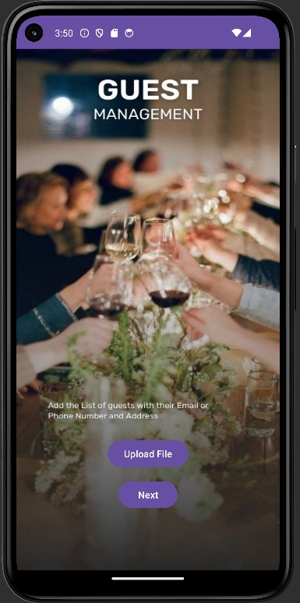

**Guestmanagement.java**package com.example.eventplanning1;  
  
import android.content.ContentResolver;  
import android.content.ContentValues;  
import android.content.Intent;  
import android.database.sqlite.SQLiteDatabase;  
import android.net.Uri;  
import android.os.Bundle;  
import android.util.Log;  
import android.view.View;  
import android.widget.Button;  
  
import androidx.activity.result.ActivityResultLauncher;  
import androidx.activity.result.contract.ActivityResultContracts;  
import androidx.appcompat.app.AppCompatActivity;  
  
import java.io.ByteArrayOutputStream;  
import java.io.IOException;  
import java.io.InputStream;  
  
public class guest_management extends AppCompatActivity {  
  
 private ActivityResultLauncher<Intent> filePickerLauncher;  
 private Button nextButton;  
 private DBHandler databaseHelper;  
  
 @Override  
 protected void onCreate(Bundle savedInstanceState) {  
 super.onCreate(savedInstanceState);  
 setContentView(R.layout.*activity_guest_management*);  
  
 // Initialize the database helper  
 databaseHelper = new DBHandler(this);  
  
 // Initialize file picker launcher  
 filePickerLauncher = registerForActivityResult(  
 new ActivityResultContracts.StartActivityForResult(),  
 result -> {  
 if (result.getResultCode() == *RESULT_OK* && result.getData() != null) {  
 Uri fileUri = result.getData().getData();  
 byte[] fileData = readFile(fileUri);  
 if (fileData != null) {  
 saveFileToDatabase(fileData);  
 }  
 }  
 });  
  
 // Find the upload button  
 View uploadButton = findViewById(R.id.*btnupload*);  
 nextButton = findViewById(R.id.*btnnext4*);  
  
 // Set click listener on upload button  
 uploadButton.setOnClickListener(v -> {  
 // Launch file picker intent  
 Intent intent = new Intent(Intent.*ACTION_GET_CONTENT*);  
 intent.setType("*/*"); // Set MIME type to filter the files  
 filePickerLauncher.launch(intent);  
 });  
  
 // Set click listener on next button  
 nextButton.setOnClickListener(v -> {  
 // Start the contact_us activity  
 Intent intent = new Intent(guest_management.this, contact_us.class);  
 startActivity(intent);  
 });  
 }  
  
 private byte[] readFile(Uri uri) {  
 try {  
 ContentResolver contentResolver = getContentResolver();  
 InputStream inputStream = contentResolver.openInputStream(uri);  
 ByteArrayOutputStream byteArrayOutputStream = new ByteArrayOutputStream();  
 byte[] buffer = new byte[1024];  
 int bytesRead;  
 while ((bytesRead = inputStream.read(buffer)) != -1) {  
 byteArrayOutputStream.write(buffer, 0, bytesRead);  
 }  
 inputStream.close();  
 return byteArrayOutputStream.toByteArray();  
 } catch (IOException e) {  
 e.printStackTrace();  
 Log.*e*("guest_management", "Error reading file", e);  
 }  
 return null;  
 }  
  
 private void saveFileToDatabase(byte[] fileData) {  
 databaseHelper.addFile(fileData);  
 }  
}

**Guestmanagement.xml**<?xml version="1.0" encoding="utf-8"?>  
<androidx.constraintlayout.widget.ConstraintLayout xmlns:android="http://schemas.android.com/apk/res/android"  
 xmlns:app="http://schemas.android.com/apk/res-auto"  
 xmlns:tools="http://schemas.android.com/tools"  
 android:id="@+id/main"  
 android:layout_width="match_parent"  
 android:layout_height="match_parent"  
 tools:context=".guest_management">  
  
 <ImageView  
 android:id="@+id/imageView6"  
 android:layout_width="wrap_content"  
 android:layout_height="wrap_content"  
 android:scaleType="fitXY"  
 app:layout_constraintBottom_toBottomOf="parent"  
 app:layout_constraintEnd_toEndOf="parent"  
 app:layout_constraintHorizontal_bias="1.0"  
 app:layout_constraintStart_toStartOf="parent"  
 app:layout_constraintTop_toTopOf="parent"  
 app:srcCompat="@drawable/_8" />  
  
 <Button  
 android:id="@+id/btnupload"  
 android:layout_width="wrap_content"  
 android:layout_height="wrap_content"  
 android:layout_marginBottom="13dp"  
 android:text="Upload File"  
 app:layout_constraintBottom_toTopOf="@+id/btnnext4"  
 app:layout_constraintEnd_toEndOf="parent"  
 app:layout_constraintStart_toStartOf="parent" />  
  
 <Button  
 android:id="@+id/btnnext4"  
 android:layout_width="wrap_content"  
 android:layout_height="wrap_content"  
 android:layout_marginBottom="89dp"  
 android:text="Next"  
 app:layout_constraintBottom_toBottomOf="parent"  
 app:layout_constraintEnd_toEndOf="parent"  
 app:layout_constraintStart_toStartOf="parent" />  
</androidx.constraintlayout.widget.ConstraintLayout>

**Contact Us Page**

Following the guest management page, users reach the contact us page. This page displays the contact details of the company along with a "Next" button for further navigation.

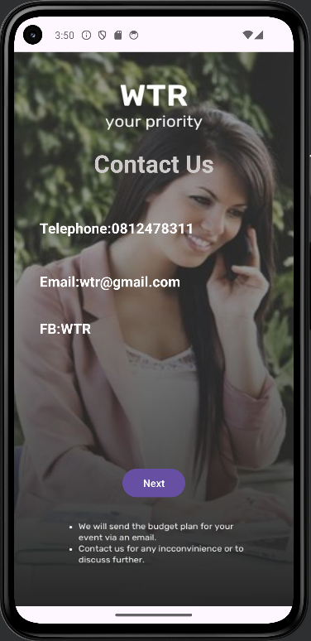

**Contactus.java**package com.example.eventplanning1;  
  
import android.content.Intent;  
import android.os.Bundle;  
import android.view.View;  
import android.widget.Button;  
  
import androidx.activity.EdgeToEdge;  
import androidx.appcompat.app.AppCompatActivity;  
import androidx.core.graphics.Insets;  
import androidx.core.view.ViewCompat;  
import androidx.core.view.WindowInsetsCompat;  
  
public class contact_us extends AppCompatActivity {  
  
 @Override  
 protected void onCreate(Bundle savedInstanceState) {  
 super.onCreate(savedInstanceState);  
 EdgeToEdge.*enable*(this);  
 setContentView(R.layout.*activity_contact_us*);  
 ViewCompat.*setOnApplyWindowInsetsListener*(findViewById(R.id.*main*), (v, insets) -> {  
 Insets systemBars = insets.getInsets(WindowInsetsCompat.Type.*systemBars*());  
 v.setPadding(systemBars.left, systemBars.top, systemBars.right, systemBars.bottom);  
 return insets;  
 });  
  
 // Initialize the next button  
 Button nextButton = findViewById(R.id.*btnnext5*); // Replace nextButtonId with your button ID  
  
 // Set click listener for the next button  
 nextButton.setOnClickListener(new View.OnClickListener() {  
 @Override  
 public void onClick(View v) {  
 // Start the next activity  
 Intent intent = new Intent(contact_us.this, thank_you.class); // Replace NextActivity.class with the desired activity  
 startActivity(intent);  
 }  
 });  
 }  
}

**Contactus.xml**<?xml version="1.0" encoding="utf-8"?>  
<androidx.constraintlayout.widget.ConstraintLayout xmlns:android="http://schemas.android.com/apk/res/android"  
 xmlns:app="http://schemas.android.com/apk/res-auto"  
 xmlns:tools="http://schemas.android.com/tools"  
 android:id="@+id/main"  
 android:layout_width="match_parent"  
 android:layout_height="match_parent"  
 tools:context=".contact_us">  
  
 <ImageView  
 android:id="@+id/email"  
 android:layout_width="wrap_content"  
 android:layout_height="wrap_content"  
 android:scaleType="fitXY"  
 app:layout_constraintStart_toStartOf="parent"  
 app:layout_constraintTop_toTopOf="parent"  
 app:srcCompat="@drawable/_14" />  
  
 <Button  
 android:id="@+id/btnnext5"  
 android:layout_width="wrap_content"  
 android:layout_height="wrap_content"  
 android:layout_marginBottom="149dp"  
 android:text="Next"  
 app:layout_constraintBottom_toBottomOf="parent"  
 app:layout_constraintEnd_toEndOf="parent"  
 app:layout_constraintStart_toStartOf="parent" />  
  
 <TextView  
 android:id="@+id/tp"  
 android:layout_width="wrap_content"  
 android:layout_height="wrap_content"  
 android:layout_marginStart="36dp"  
 android:layout_marginTop="233dp"  
 android:text="Telephone:0812478311"  
 android:textColor="#FAF8F8"  
 android:textSize="20sp"  
 android:textStyle="bold"  
 app:layout_constraintStart_toStartOf="parent"  
 app:layout_constraintTop_toTopOf="parent" />  
  
 <TextView  
 android:id="@+id/fb"  
 android:layout_width="wrap_content"  
 android:layout_height="wrap_content"  
 android:layout_marginStart="36dp"  
 android:layout_marginTop="39dp"  
 android:text="FB:WTR "  
 android:textColor="#F8F6F6"  
 android:textSize="20sp"  
 android:textStyle="bold"  
 app:layout_constraintStart_toStartOf="parent"  
 app:layout_constraintTop_toBottomOf="@+id/mail" />  
  
 <TextView  
 android:id="@+id/mail"  
 android:layout_width="wrap_content"  
 android:layout_height="wrap_content"  
 android:layout_marginStart="36dp"  
 android:layout_marginTop="48dp"  
 android:text="Email:wtr@gmail.com"  
 android:textColor="#FDFCFC"  
 android:textSize="20sp"  
 android:textStyle="bold"  
 app:layout_constraintStart_toStartOf="parent"  
 app:layout_constraintTop_toBottomOf="@+id/tp" />  
  
 <TextView  
 android:id="@+id/cntact"  
 android:layout_width="wrap_content"  
 android:layout_height="wrap_content"  
 android:layout_marginBottom="54dp"  
 android:text="Contact Us"  
 android:textColor="#CFCACA"  
 android:textSize="34sp"  
 android:textStyle="bold"  
 app:layout_constraintBottom_toTopOf="@+id/tp"  
 app:layout_constraintEnd_toEndOf="parent"  
 app:layout_constraintStart_toStartOf="parent" />  
  
</androidx.constraintlayout.widget.ConstraintLayout>

**Thank You Page**

This page is dedicated to thanking the client. It includes a button to move to the account management page.

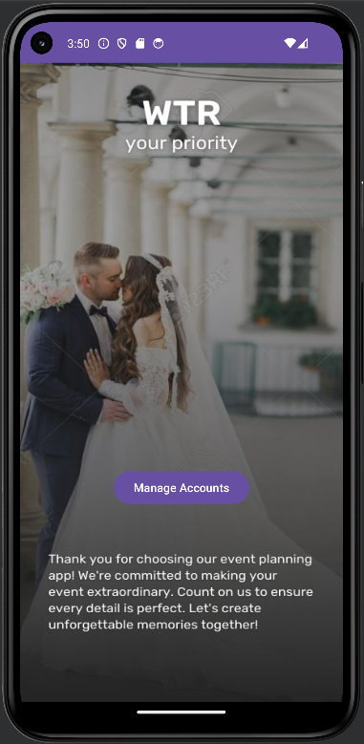

**Thankyou.java**package com.example.eventplanning1;  
  
import android.content.Intent;  
import android.os.Bundle;  
import android.view.View;  
import android.widget.Button;  
  
import androidx.appcompat.app.AppCompatActivity;  
  
public class thank_you extends AppCompatActivity {  
  
 @Override  
 protected void onCreate(Bundle savedInstanceState) {  
 super.onCreate(savedInstanceState);  
 setContentView(R.layout.*activity_thank_you*);  
  
 // Assuming you have a manager button with id btn_manager in your layout XML  
 Button manageAccountButton = findViewById(R.id.*mgnactbtn*);  
 manageAccountButton.setOnClickListener(new View.OnClickListener() {  
 @Override  
 public void onClick(View v) {  
 // Start the entry activity  
 Intent intent = new Intent(thank_you.this, entry.class);  
 startActivity(intent);  
 }  
 });  
 }  
}

**Thankyou.xml**<?xml version="1.0" encoding="utf-8"?>  
<androidx.constraintlayout.widget.ConstraintLayout xmlns:android="http://schemas.android.com/apk/res/android"  
 xmlns:app="http://schemas.android.com/apk/res-auto"  
 xmlns:tools="http://schemas.android.com/tools"  
 android:id="@+id/main"  
 android:layout_width="match_parent"  
 android:layout_height="match_parent"  
 tools:context=".thank_you">  
  
 <ImageView  
 android:id="@+id/imageView8"  
 android:layout_width="wrap_content"  
 android:layout_height="wrap_content"  
 android:scaleType="fitXY"  
 app:layout_constraintBottom_toBottomOf="parent"  
 app:layout_constraintEnd_toEndOf="parent"  
 app:layout_constraintHorizontal_bias="0.0"  
 app:layout_constraintStart_toStartOf="parent"  
 app:layout_constraintTop_toTopOf="parent"  
 app:srcCompat="@drawable/_15" />  
  
 <Button  
 android:id="@+id/mgnactbtn"  
 android:layout_width="wrap_content"  
 android:layout_height="wrap_content"  
 android:layout_marginBottom="237dp"  
 android:text="Manage Accounts"  
 app:layout_constraintBottom_toBottomOf="parent"  
 app:layout_constraintEnd_toEndOf="parent"  
 app:layout_constraintStart_toStartOf="parent" />  
</androidx.constraintlayout.widget.ConstraintLayout>

**Management Page**

After the thank you page, users access the manage your account page. Here, user can view user details by entering their email and clicking the "View details" button. Additionally, there is an option to delete details. Users can navigate to the thank you page using the "Exit" button.

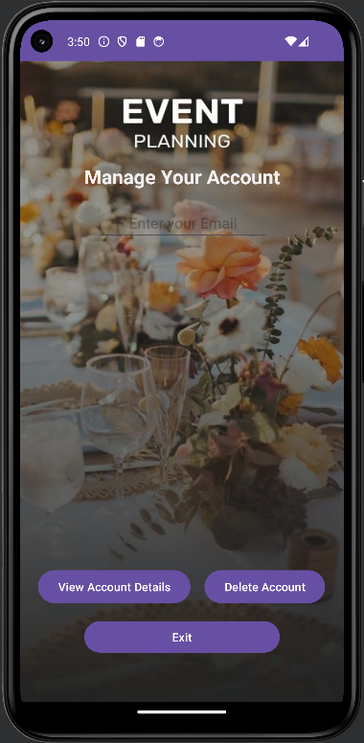

Management.java  
package com.example.eventplanning1;  
  
  
  
import android.annotation.SuppressLint;  
import android.content.Intent;  
import android.os.Bundle;  
import android.text.TextUtils;  
import android.view.View;  
import android.widget.ArrayAdapter;  
import android.widget.Button;  
import android.widget.EditText;  
import android.widget.ListView;  
import android.widget.Toast;  
  
import androidx.appcompat.app.AppCompatActivity;  
import java.util.ArrayList;  
  
public class entry extends AppCompatActivity {  
  
 private ListView listView;  
 private DBHandler dbHelper;  
 private EditText emailEditText;  
 private Button viewbtn;  
  
 private Button deleteBtn;  
  
 @SuppressLint("MissingInflatedId")  
 @Override  
 protected void onCreate(Bundle savedInstanceState) {  
 super.onCreate(savedInstanceState);  
 setContentView(R.layout.*activity_account_management*);  
  
 emailEditText = findViewById(R.id.*txtEmailA*);  
 listView = findViewById(R.id.*listView*);  
 viewbtn = findViewById(R.id.*btn_read*);  
 deleteBtn = findViewById(R.id.*btn_delete*);  
  
  
  
 dbHelper = new DBHandler(this);  
  
 viewbtn.setOnClickListener(new View.OnClickListener() {  
 @Override  
 public void onClick(View v) {  
 String email = emailEditText.getText().toString().trim();  
 if (!TextUtils.*isEmpty*(email)) {  
 ArrayList<String> list = dbHelper.getCustomerByEmail(email);  
 ArrayAdapter<String> adapter = new ArrayAdapter<>(entry.this, R.layout.*list_item1*, list);  
 listView.setAdapter(adapter);  
 } else {  
 Toast.*makeText*(entry.this, "Please enter an email", Toast.*LENGTH_SHORT*).show();  
 }  
 }  
 });  
  
 deleteBtn.setOnClickListener(new View.OnClickListener() {  
 @Override  
 public void onClick(View v) {  
 String email = emailEditText.getText().toString().trim();  
 if (!TextUtils.*isEmpty*(email)) {  
 dbHelper.deleteCustomerByEmail(email);  
 Toast.*makeText*(entry.this, "Customer deleted successfully", Toast.*LENGTH_SHORT*).show();  
 } else {  
 Toast.*makeText*(entry.this, "Please enter an email", Toast.*LENGTH_SHORT*).show();  
 }  
 }  
 });  
  
  
 }  
  
  
 public void clear(View view) {  
 emailEditText.setText("");  
 }  
  
 public void goHome(View view) {  
 startActivity(new Intent(entry.this, thank_you.class));  
 }  
}

Accounthandler.java  
package com.example.eventplanning1;  
  
import android.os.Bundle;  
  
import androidx.activity.EdgeToEdge;  
import androidx.appcompat.app.AppCompatActivity;  
import androidx.core.graphics.Insets;  
import androidx.core.view.ViewCompat;  
import androidx.core.view.WindowInsetsCompat;  
  
public class accountHandle extends AppCompatActivity {  
  
 @Override  
 protected void onCreate(Bundle savedInstanceState) {  
 super.onCreate(savedInstanceState);  
 EdgeToEdge.*enable*(this);  
 setContentView(R.layout.*activity_account_handle*);  
 ViewCompat.*setOnApplyWindowInsetsListener*(findViewById(R.id.*main*), (v, insets) -> {  
 Insets systemBars = insets.getInsets(WindowInsetsCompat.Type.*systemBars*());  
 v.setPadding(systemBars.left, systemBars.top, systemBars.right, systemBars.bottom);  
 return insets;  
 });  
 }  
}

Management.xml  
<?xml version="1.0" encoding="utf-8"?>  
<androidx.constraintlayout.widget.ConstraintLayout xmlns:android="http://schemas.android.com/apk/res/android"  
 xmlns:app="http://schemas.android.com/apk/res-auto"  
 xmlns:tools="http://schemas.android.com/tools"  
 android:id="@+id/main"  
 android:layout_width="match_parent"  
 android:layout_height="match_parent"  
 android:background="@drawable/_1"  
 tools:context=".entry">  
  
  
 <TextView  
 android:id="@+id/txtmanage"  
 android:layout_width="wrap_content"  
 android:layout_height="wrap_content"  
 android:layout_marginTop="124dp"  
 android:layout_marginBottom="18dp"  
 android:text="Manage Your Account"  
 android:textColor="#F3EFEF"  
 android:textSize="24sp"  
 android:textStyle="bold"  
 app:layout_constraintBottom_toTopOf="@+id/txtEmailA"  
 app:layout_constraintEnd_toEndOf="parent"  
 app:layout_constraintStart_toStartOf="parent"  
 app:layout_constraintTop_toTopOf="parent" />  
  
 <ListView  
 android:id="@+id/listView"  
 android:layout_width="0dp"  
 android:layout_height="0dp"  
 android:layout_marginStart="32dp"  
 android:layout_marginEnd="32dp"  
 android:layout_marginBottom="16dp"  
 app:layout_constraintBottom_toTopOf="@+id/btn_read"  
 app:layout_constraintEnd_toEndOf="parent"  
 app:layout_constraintStart_toStartOf="parent"  
 app:layout_constraintTop_toBottomOf="@+id/txtEmailA">  
  
  
 </ListView>  
  
 <Button  
 android:id="@+id/btn_read"  
 android:layout_width="wrap_content"  
 android:layout_height="wrap_content"  
 android:layout_marginEnd="17dp"  
  
 android:layout_marginBottom="116dp"  
 android:text="View Account Details"  
 app:layout_constraintBottom_toBottomOf="parent"  
 app:layout_constraintEnd_toStartOf="@+id/btn_delete"  
 app:layout_constraintHorizontal_chainStyle="packed"  
 app:layout_constraintStart_toStartOf="parent"  
 app:layout_constraintTop_toBottomOf="@+id/listView" />  
  
 <Button  
 android:id="@+id/btnexit"  
 android:layout_width="237dp"  
 android:layout_height="46dp"  
 android:layout_marginBottom="56dp"  
 android:text="Exit"  
 app:layout_constraintBottom_toBottomOf="parent"  
 app:layout_constraintEnd_toEndOf="parent"  
 app:layout_constraintStart_toStartOf="parent" />  
  
 <EditText  
 android:id="@+id/txtEmailA"  
 android:layout_width="wrap_content"  
 android:layout_height="wrap_content"  
 android:layout_marginStart="14dp"  
 android:layout_marginBottom="35dp"  
 android:ems="10"  
 android:hint="Enter your Email"  
 android:inputType="text"  
 android:textAlignment="center"  
 android:textColor="#FBF9F9"  
 app:layout_constraintBottom_toTopOf="@+id/listView"  
 app:layout_constraintStart_toStartOf="@+id/txtmanage"  
 app:layout_constraintTop_toBottomOf="@+id/txtmanage" />  
  
 <Button  
 android:id="@+id/btn_delete"  
 android:layout_width="wrap_content"  
 android:layout_height="wrap_content"  
 android:layout_marginEnd="1dp"  
 android:layout_marginBottom="116dp"  
 android:text="Delete Account"  
 app:layout_constraintBottom_toBottomOf="parent"  
 app:layout_constraintEnd_toEndOf="parent"  
 app:layout_constraintStart_toEndOf="@+id/btn_read" />  
  
</androidx.constraintlayout.widget.ConstraintLayout>

Listitemxml  
<?xml version="1.0" encoding="utf-8"?>  
<TextView xmlns:android="http://schemas.android.com/apk/res/android"  
 android:orientation="vertical"  
 android:layout_width="match_parent"  
 android:layout_height="match_parent"  
 android:textSize="20sp">  
  
</TextView>

Accounthandle.xml  
<?xml version="1.0" encoding="utf-8"?>  
<androidx.constraintlayout.widget.ConstraintLayout xmlns:android="http://schemas.android.com/apk/res/android"  
 xmlns:app="http://schemas.android.com/apk/res-auto"  
 xmlns:tools="http://schemas.android.com/tools"  
 android:id="@+id/main"  
 android:layout_width="match_parent"  
 android:layout_height="match_parent"  
 tools:context=".accountHandle">  
  
</androidx.constraintlayout.widget.ConstraintLayout>

Manifest.xml  
<?xml version="1.0" encoding="utf-8"?>  
<manifest xmlns:android="http://schemas.android.com/apk/res/android"  
 xmlns:tools="http://schemas.android.com/tools">  
  
 <uses-permission android:name="android.permission.INTERNET" />  
 <uses-permission android:name="android.permission.WRITE_EXTERNAL_STORAGE" />  
  
 <application  
 android:allowBackup="true"  
 android:dataExtractionRules="@xml/data_extraction_rules"  
 android:fullBackupContent="@xml/backup_rules"  
 android:icon="@mipmap/ic_launcher"  
 android:label="@string/app_name"  
 android:roundIcon="@mipmap/ic_launcher_round"  
 android:supportsRtl="true"  
 android:theme="@style/Theme.Eventplanning1"  
 tools:targetApi="31">  
 <activity  
 android:name=".accountHandle"  
 android:exported="false" />  
 <activity  
 android:name=".entry"  
 android:exported="true" />  
 <activity  
 android:name=".thank_you"  
 android:exported="true" />  
 <activity  
 android:name=".contact_us"  
 android:exported="true" />  
 <activity  
 android:name=".guest_management"  
 android:exported="true" />  
 <activity  
 android:name=".task_assignment"  
 android:exported="true" />  
 <activity  
 android:name=".MainActivty3"  
 android:exported="true"  
 tools:ignore="DuplicateActivity">  
 <intent-filter>  
 <action android:name="android.intent.action.MAIN" />  
  
 <category android:name="android.intent.category.LAUNCHER" />  
 </intent-filter>  
 </activity>  
 <activity  
 android:name=".theme"  
 android:exported="true" />  
 <activity  
 android:name=".event_creation"  
 android:exported="true" />  
 <activity  
 android:name=".sign_up"  
 android:exported="true" />  
 </application>  
  
</manifest>

Dbhandler.java  
package com.example.eventplanning1;  
  
import android.annotation.SuppressLint;  
import android.content.ContentValues;  
import android.content.Context;  
import android.database.Cursor;  
import android.database.sqlite.SQLiteDatabase;  
import android.database.sqlite.SQLiteOpenHelper;  
  
import java.util.ArrayList;  
import java.util.List;  
  
public class DBHandler extends SQLiteOpenHelper {  
  
 // Constants for database  
 private static final String *DB_NAME* = "Event_planning_db2"; // Database name  
 private static final int *DB_VERSION* = 1; // Database version  
  
 // Constants for tables  
 private static final String *REGISTER_USERS_TABLE* = "users"; // Table name  
  
 // Columns  
 private static final String *COLUMN_ID* = "id";  
 private static final String *COLUMN_EMAIL* = "email";  
 private static final String *COLUMN_FULLNAME* = "fullname";  
 private static final String *COLUMN_USERNAME* = "username";  
 private static final String *COLUMN_PASSWORD* = "password";  
 private static final String *COLUMN_THEME_NAME* = "theme_name";  
 private static final String *COLUMN_PREFERENCES* = "preferences";  
 private static final String *COLUMN_EVENT_TYPE* = "event_type";  
 private static final String *COLUMN_EVENT_DATE* = "date";  
 private static final String *COLUMN_FILE_DATA* = "file_data";  
 private static final String *COLUMN_NEEDED_ITEMS* = "items";  
  
  
 // Constructor  
 public DBHandler(Context context) {  
 super(context, *DB_NAME*, null, *DB_VERSION*);  
 }  
  
 @Override  
 public void onCreate(SQLiteDatabase db) {  
 // Create users table  
 String createTableQuery = "CREATE TABLE " + *REGISTER_USERS_TABLE* + " (" +  
 *COLUMN_ID* + " INTEGER PRIMARY KEY AUTOINCREMENT," +  
 *COLUMN_EMAIL* + " TEXT," +  
 *COLUMN_FULLNAME* + " TEXT," +  
 *COLUMN_USERNAME* + " TEXT," +  
 *COLUMN_PASSWORD* + " TEXT," +  
 *COLUMN_THEME_NAME* + " TEXT," +  
 *COLUMN_PREFERENCES* + " TEXT," +  
 *COLUMN_EVENT_TYPE* + " TEXT," +  
 *COLUMN_EVENT_DATE* + " TEXT," +  
 *COLUMN_FILE_DATA* + " BLOB," +  
 *COLUMN_NEEDED_ITEMS* + " TEXT" +  
 ")";  
 db.execSQL(createTableQuery);  
 }  
  
 @Override  
 public void onUpgrade(SQLiteDatabase db, int oldVersion, int newVersion) {  
 // Upgrade logic here if needed  
 }  
  
 // Add user to the database  
 public boolean addUser(String email, String fullName, String username, String password) {  
 SQLiteDatabase db = this.getWritableDatabase();  
 ContentValues values = new ContentValues();  
 values.put(*COLUMN_EMAIL*, email);  
 values.put(*COLUMN_FULLNAME*, fullName);  
 values.put(*COLUMN_USERNAME*, username);  
 values.put(*COLUMN_PASSWORD*, password);  
 long result = db.insert(*REGISTER_USERS_TABLE*, null, values);  
 db.close();  
 return result != -1;  
 }  
  
 // Read user data from the database  
 public String getUserData() {  
 SQLiteDatabase db = this.getReadableDatabase();  
 Cursor cursor = db.query(*REGISTER_USERS_TABLE*, null, null, null, null, null, null);  
 StringBuilder userData = new StringBuilder();  
 while (cursor.moveToNext()) {  
 @SuppressLint("Range")  
 String email = cursor.getString(cursor.getColumnIndex(*COLUMN_EMAIL*));  
 @SuppressLint("Range") String fullName = cursor.getString(cursor.getColumnIndex(*COLUMN_FULLNAME*));  
 @SuppressLint("Range") String username = cursor.getString(cursor.getColumnIndex(*COLUMN_USERNAME*));  
 userData.append("Email: ").append(email)  
 .append(", Full Name: ").append(fullName)  
 .append(", Username: ").append(username)  
 .append("\n");  
 }  
 cursor.close();  
 return userData.toString();  
 }  
  
 // Update user account in the database  
 public boolean updateUser(String email, String newFullName, String newPassword) {  
 SQLiteDatabase db = this.getWritableDatabase();  
 ContentValues values = new ContentValues();  
 values.put(*COLUMN_FULLNAME*, newFullName);  
 values.put(*COLUMN_PASSWORD*, newPassword);  
 int rowsAffected = db.update(*REGISTER_USERS_TABLE*, values, *COLUMN_EMAIL* + "=?", new String[]{email});  
 db.close();  
 return rowsAffected > 0;  
 }  
  
 // Delete user account from the database  
 public boolean deleteUser(String email) {  
 SQLiteDatabase db = this.getWritableDatabase();  
 int rowsAffected = db.delete(*REGISTER_USERS_TABLE*, *COLUMN_EMAIL* + "=?", new String[]{email});  
 db.close();  
 return rowsAffected > 0;  
 }  
  
 // Add a new theme and preferences to the database  
 public void addNewtheme(String themeName, String preferences) {  
 SQLiteDatabase db = this.getWritableDatabase();  
 ContentValues values = new ContentValues();  
 values.put(*COLUMN_THEME_NAME*, themeName);  
 values.put(*COLUMN_PREFERENCES*, preferences);  
 db.update(*REGISTER_USERS_TABLE*, values, *COLUMN_ID* + "=1", null);  
 db.close();  
 }  
  
 // Add a new event creation to the database  
 public void eventCreation(String selectedEvent, String eventDate) {  
 SQLiteDatabase db = this.getWritableDatabase();  
 ContentValues values = new ContentValues();  
 values.put(*COLUMN_EVENT_TYPE*, selectedEvent);  
 values.put(*COLUMN_EVENT_DATE*, eventDate);  
 db.update(*REGISTER_USERS_TABLE*, values, *COLUMN_ID* + "=1", null);  
 db.close();  
 }  
  
 // Check login credentials  
 public boolean checkLogin(String email, String password) {  
 SQLiteDatabase db = this.getReadableDatabase();  
 String[] columns = {*COLUMN_EMAIL*};  
 String selection = *COLUMN_EMAIL* + "=? AND " + *COLUMN_PASSWORD* + "=?";  
 String[] selectionArgs = {email, password};  
 Cursor cursor = db.query(*REGISTER_USERS_TABLE*, columns, selection, selectionArgs, null, null, null);  
 int count = cursor.getCount();  
 cursor.close();  
 return count > 0;  
 }  
  
 public void addFile(byte[] fileData) {  
 SQLiteDatabase db = this.getWritableDatabase();  
 ContentValues values = new ContentValues();  
 values.put(*COLUMN_FILE_DATA*, fileData);  
 db.update(*REGISTER_USERS_TABLE*, values, *COLUMN_ID* + "=1", null);  
 db.close();  
 }  
 public void addChecklistItems(List<String> items) {  
 SQLiteDatabase db = this.getWritableDatabase();  
 for (String item : items) {  
 ContentValues values = new ContentValues();  
 values.put(*COLUMN_NEEDED_ITEMS*, item);  
 db.insert(*REGISTER_USERS_TABLE*, null, values);  
 }  
 db.close();  
 }  
  
 public ArrayList<String> getCustomerByEmail(String email) {  
 ArrayList<String> customerDetails = new ArrayList<>();  
 SQLiteDatabase db = getReadableDatabase();  
 String selection = *COLUMN_EMAIL* + "=?";  
 String[] selectionArgs = { email };  
 Cursor cursor = db.query(*REGISTER_USERS_TABLE*, null, selection, selectionArgs, null, null, null);  
 if (cursor != null && cursor.moveToFirst()) {  
 do {  
 StringBuilder rowData = new StringBuilder();  
 int columnCount = cursor.getColumnCount();  
 for (int i = 0; i < columnCount; i++) {  
 String columnName = cursor.getColumnName(i);  
 String columnValue = cursor.getString(i);  
 rowData.append(columnName).append(": ").append(columnValue).append("\n");  
 }  
 customerDetails.add(rowData.toString());  
 } while (cursor.moveToNext());  
 cursor.close();  
 }  
 return customerDetails;  
 }  
 public void deleteCustomerByEmail(String email) {  
 SQLiteDatabase db = getWritableDatabase();  
 String whereClause = *COLUMN_EMAIL* + "=?";  
 String[] whereArgs = { email };  
 db.delete(*REGISTER_USERS_TABLE*, whereClause, whereArgs);  
 }  
  
}